Vectors and spaces

Lesson 1: Vectors

* Vector: Magnitude + Direction



* Denoted as an Arrow
* length of arrow is magnitude
* the way of pointing is the direction
* the notation of representing it by 2 numbers when in a 2D space, gives the point in 2D space that can be joined to the origin to visualize the arrow
* Real coordinate space -> R2 : All possible real-valued 2-tuples
* The ‘2’ represents the number of dimensions
* Uses 2 numbers (Real Numbers) to represent
* Similarly, R3 can also be used
* X with arrow∈ double-struck R3 represents that it is a vector in 3D space
* Vector addition
* It can be done by simply adding each component
* This can be visualized by placing the tail of vector ‘b’ and head of vector ‘a’ and draw a vector from vector ‘a’ tail to vector ‘b’ head
* Vector multiplication with scalar
* The scalar value can be separately multiplied by each component of the vector
* It most of the time changes only the magnitude, unless the scalar value is negative

Vector Examples

Unit Vectors

* = (1,0)



* j hat = (0, 1)

Parametric representation

* a :



* A scalar multiplied by a vector will give us Set of collinear vectors

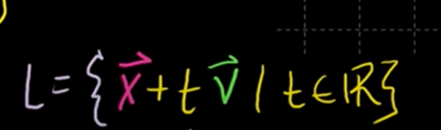

* The L gives the parametric representation
* 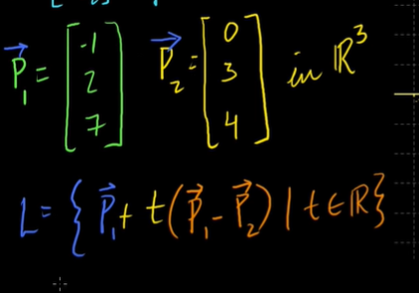the formula can be used with an example like this to obtain the parametric representation on a line that passes through P1 and P2

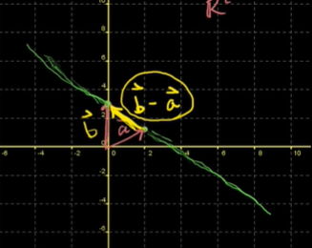

Lesson 2: Linear combinations and spans